School Supply List for
2024-2025 School Year

1 Backpack (soft-sided, NO wheels)

1 package of 4 - BLACK ONLY Fine Tip dry erase markers
1 pack of regular (3”x3”) sized post-its
4 pack of Highlighters (Broad tipped)
1 pack of WIDE ruled loose-leaf (150 sheet filler) paper
1 Black Composition Notebook, Wide Ruled, 100 Sheets
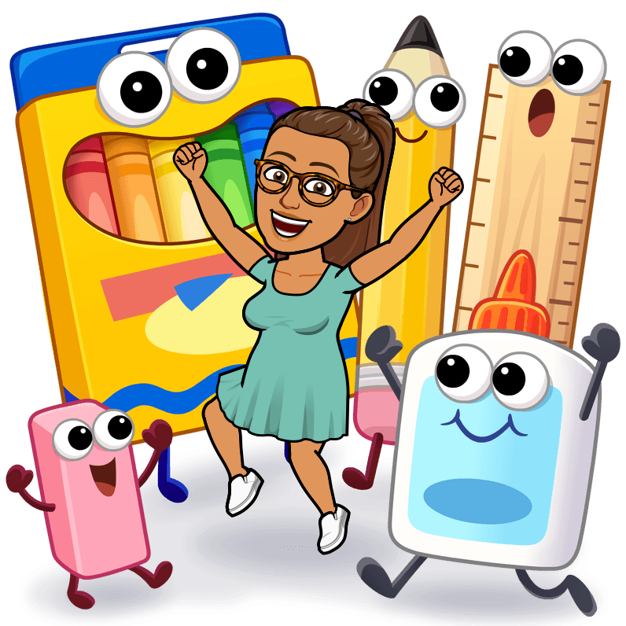
2 - 1 Subject Spiral Notebooks Wide Ruled, 70 Sheets

Boys -
2-3 rolls of paper towels
1 box of Quart sized Ziploc bags
1 Clorox Wipes Canister

Girls -
2-3 boxes of tissues – large box 160 2 ply
1 box of Pint size Ziploc bags
1 Clorox Wipes Canister

(optional)
earbuds or headphones for use with iPad
1 refillable water bottle, with lid, for use in class

